# Introduction to Interface

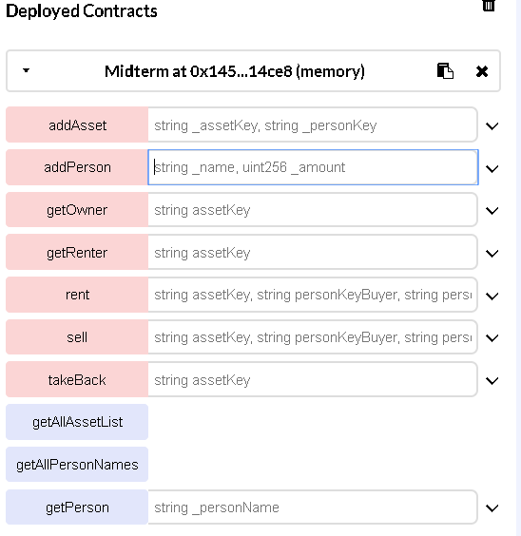

# Adding a person



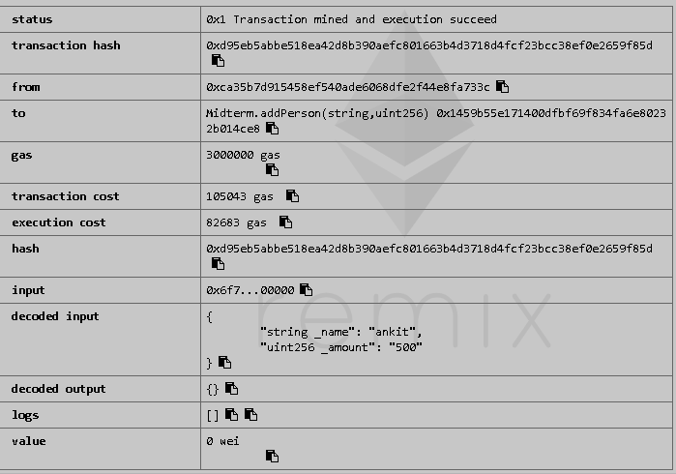

# Creating an Asset





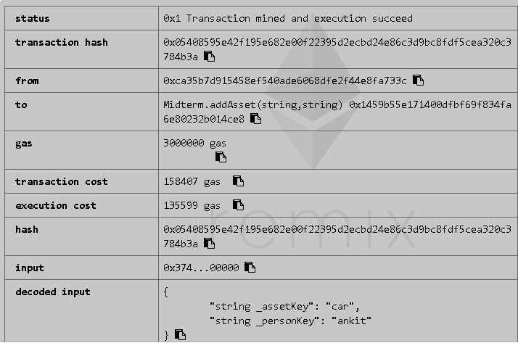

# Selling the asset





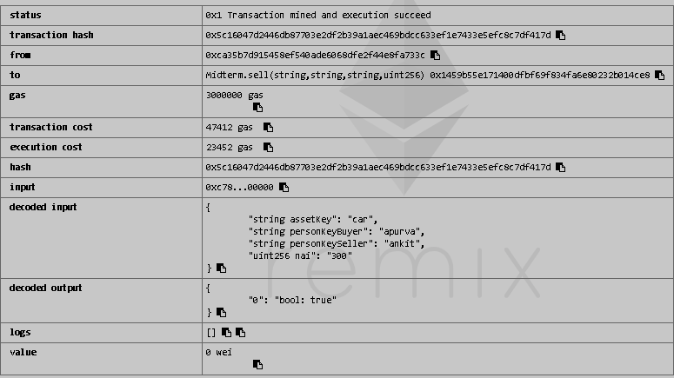

# Checking the owner



**It’s a hash value of Person’s key + Asset key**

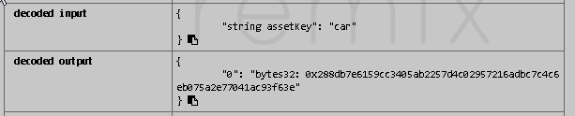

# Getting renter value



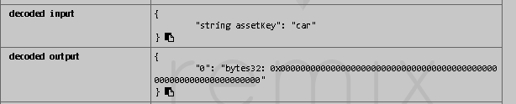

The output is 0, it means it has not been rented. It is in possession of the owner



# Verifing Person

**Using getPerson function**

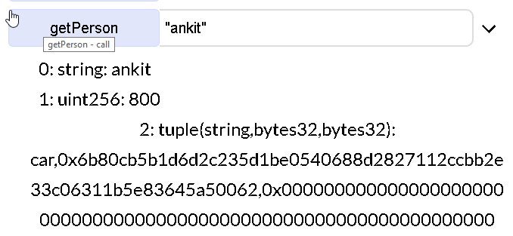

**Notice the change in nai value with Ankit => it is 500 + 300 (asset selling price)**



# Selling: fail case

**Let’s try reselling the asset**



**Notice the change in selling price**

This is to test, because **Apurva has only 200 Nai left** in her account

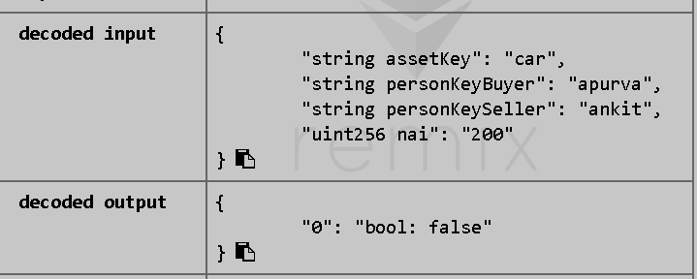

The output is still false because Ankit is not the owner of the asset.

A hash check function is involved here which denies the transaction

The asset was already sold to Apurva.

Let’s try swapping the buyer and the seller



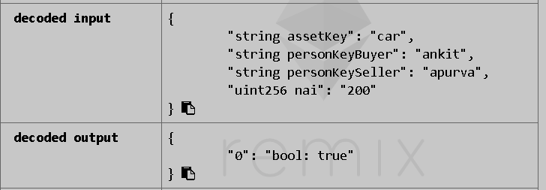

**Now it is a success. Notice the change in Nai amount below. Apurva has 400 Nais**

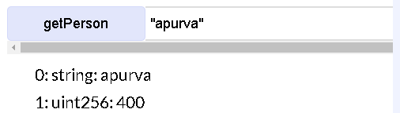

# Renting an asset

**Lets see the Renting or allow-use use case**



**Ankit was able to rent the car because he is the owner**



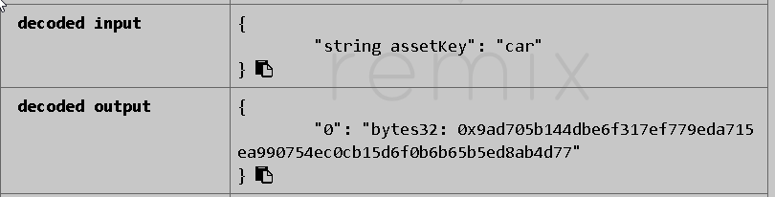

**Now get renter does not return 0**

**Instead it returns a hash value of Apurva’s key. Because she has borrowed the asset from the owner.**

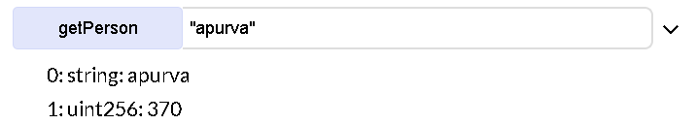

**Notice the Nai change in Apurva’s account**

# Renting: fail case

**Let’s try a case where Apurva is renting the asset further to Vijay**



**Notice below the output**

**It returns false, because Apurva does not owns the asset**

